University of Petra |  | 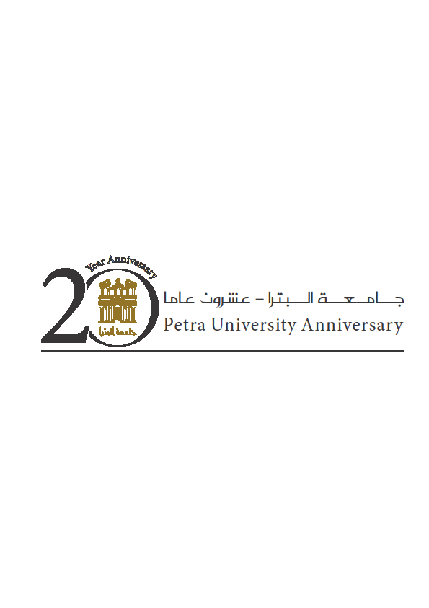
Faculty of Information Technology |  | كلية تكنولوجيا المعلومات
Department of Computer Information Systems |  | قسم نظم المعلومات الحاسوبية

Course Syllabus

Year: 2019-2020 Semester: (1)

Course No. | Course Title | Prerequisite | Co-requisite | Credit Hours  Lectures / Lab.
602211 | Visual Programming | 601212 |  | 3:3:2 Lab

Instructor Name | E-mail | Office No. | Office ext. | Office Hours

Coordinator's Name:

Short Course Description | This course introduces the concepts of visual programming environment and Object-Oriented Programming features. Topics covered study of MS.net platform including architecture, multi languages, FCL, CLR, Compilation of applications and execution. Further work includes: C Sharp Dot Net (C#.net) Integrated Development Environment (IDE), graphical user interface (GUI) design , control tools, event handling, control structures, methods, classes, objects, exception handling, graphics, and files input output instructions.

Course Objectives
- Understand C# .NET terminology and architecture.
- Master programming fundamentals, including variables, decision structures, loops, and functions.
- Deal with the standard toolbox inorder to design appealing and effective graphical user interfaces using a variety of C#.Net controls.
- Develop meaningful Windows Applications in C# .NET, including dialog boxes, clocks, menus, toolbars,multi-documented applications.
- Handle with graphics and animation effects.
- Write user own classes using object oriented programming concepts.

Course Intended Learning Outcomes (ILOs) and their Alignment with Program ILOs, Teaching and Learning Methods, and Assessment Methods:

Upon successful completion of this course, students are expected to achieve the following learning outcomes:

Course ILOs | Program ILOs | Teaching and Learning Method | Assessment Method
Knowledge (K)
K1. Learn the concept of event driven programming | A.2 | Interactive lectures | 1st Exam
K2. Recognize the Visual studio environment. | A.2 | Interactive lectures | 1st Exam
K3. Learn file streaming concepts. | A.2 | Interactive lectures | 1st Exam
Intellectual Skills (I)
I1. Analyze a problem to design windows based solutions. | B.3 | Interactive lectures &VP Labs | 2nd Exam
I2. Choose appropriate controls to design the GUI to meet desired needs. | C.1 | Interactive lectures &VP Labs | 1st Exam
Practical skills (P)
P1. Use different control structures, functions and sub procedures and data types to solve a problem | C.2 | Interactive lectures &VP Labs | Final Exam
P2. Create and read sequential files. | C.2 | Interactive lectures &VP Labs | Final Exam
P3. Develop windows applications using C#.NET | I.3 | Interactive lectures &VP Labs | 2nd Exam
P4. Use exception handling techniques. | C.3 | Interactive lectures &VP Labs | Final Exam
Transferable Skills (T)
T1. Develop a logical thinking to solve a problem | A.3 | Interactive lectures | 2nd Exam

Course Schedule:

Week | Topics | Topic Details | Course ILO number | Reference (chapter)
1 | Introduction to Visual Programming | Understanding how to build a Visual program in different programming languages. | K1,K2
1 | Introduction to C#.Net and Visual Studio: Part 1 | Using the Visual Studio environment, Navigating the Visual Studio 2010 IDE  Similarities between Java and C#.Net | K1,K2 | 1,2
2 | Introduction to C#.Net and Visual Studio: Part 2 | The general structure of the C#.net, create a simple application. | K1,K2 | 3
2 | Mastering the C#.Net language: Part 1 | Data types, Operators, Conditional statements  - Keywords, built-in Statements  - Variables, Data Conversions  - Math operations | K3,I1,I2,P1,P3 | 3
2,3 | Object Oriented Programming | - Classes and Objects  - Constructors  - Methods and properties  - Built-in methods (Strings, Math, Random) | K3,I1,I2,P1,P2,P3 | 4, 7, 10
3,4 | Mastering the C#.Net language: Part 2 | - If statements, switch statements and breaks.  - For loop, For each loop, While loop  - Declaring arrays and Lists  - LINQ | K3,I1,I2,P1,P3 | 3, 5, 6, 8, 9
4 | Creating Windows Forms | Graphical User interface Concepts :Windows forms, Components and Controls  - Creating Windows Applications  - Windows Forms in code  - Using the Built- in Messages Box. | K3,I1,I2,P1,P3 | 14
5 | C#.NET Controls: part1 | - Text Boxes  - Buttons, Labels  - Check Boxes  - Radio Buttons  - Creating new forms | K3,I1,I2,P1,P3 | 14
 |  | First Exam
5 | Exception handling | Procedures and Error Handling.  - Understanding Scope  - Understanding Exception Handling  - How to debug the code. | K3,I1,I2,P1,P3 | 4, 7, 8, 13
6,7 | C#.NET Controls: part2 | - List Boxes  - Combo Boxes  - Picture Boxes  - Working with timers  - DateTime data type  - Tool Tips  - NumericUpDown | K3,I1,I2,P1,P2,P3 | 15
8,9 | Menus dialogs, and advanced controls | Working with Menus, Built- in Dialogs  - Using Menus  - Using Context Menus  - Using the Built-in Dialogs  - Toolbar  - Status Bars  - Progress Bar  - Tab control | K3,I1,I2,P1,P2,P3 | 15
10 | Files and Database connectivity | - File I/O Stream  - Database connection. | K3,I1,I2,P1,P2,P3 | 17
10 | Strings | - Charaters and strings  - Strings manipulation | K3,I1,I2,P1,P2,P3 | 16
 |  | Second Exam
11,12 | Keyboard and mouse events,  graphics and validating user Input | - keydown and keyup  - The validating and validated events  - Mouse events  - Drawing Lines, Rectangles and Ovals  - Creating Text Boxes, Buttons, labels at run time. | K3,I1,I2,P1,P2,P3 | 14
13 | Data structures | - Linked Lists  - Stack  - Queue  - Dictionary | K3,I1,I2,P1,P2,P3,T1 | 19, 21
14 | Byond Forms | - Introduction to WPF  - Difference between form application and WPF. | K3,I1,I2,P1,P2,P3
15 |  | Final Exam

Assessment Methods and Grading System:

Assessment method | Grade | Comments
Lab work | 20
Project | 10
First Exam | 15
Second Exam | 15
A Comprehensive Final examination | 40
Total | 100

Learning References:

1- Textbook (s):
Visual C# How to Program, H. Deitel, P. Deitel, ISBN: 9780134601540, Pearson International edition, 6th edition ,2018.
2- References:
[R1] C# Fundamentals for Absolute Beginners Course, Microsoft Virtual Academy.
[R2] Lecture Notes.
[R3] C# 6.0 in a Nutshell: The Definitive Reference, B. Albahari, J. Albahari, ISBN: 9781491927069, O'Reilly Media, 6th edition, 2015.
3- Other Resources:
<<Labs, computer resources, lecture rooms needed for the course>>

Course Policies

- Attendance Policy: University regulations apply to attendance.

- Academic Honesty: Academic dishonesty is an unacceptable mode of conduct, and will not be tolerated in any form at University of Petra. All persons involved in academic dishonesty and plagiarism in any form will be disciplined in accordance with University rules and regulations.

Approved by | Name | Date | Signature
Coordinator of Curriculum Committee
Faculty Dean/ Head of Department

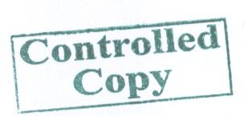

Additional information may be added in this section according to the nature of the course.

